Optional Homework 2 Report
Rohan Krishnamurthi
10/29/2024

Multiqc Figures:

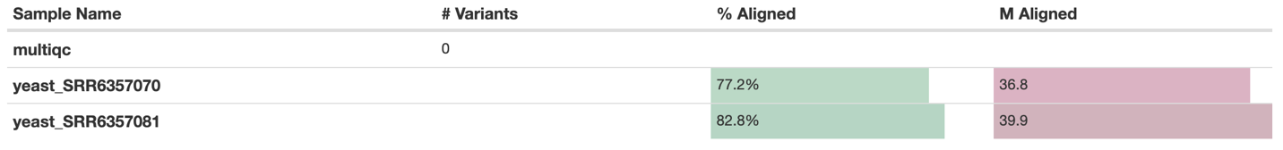

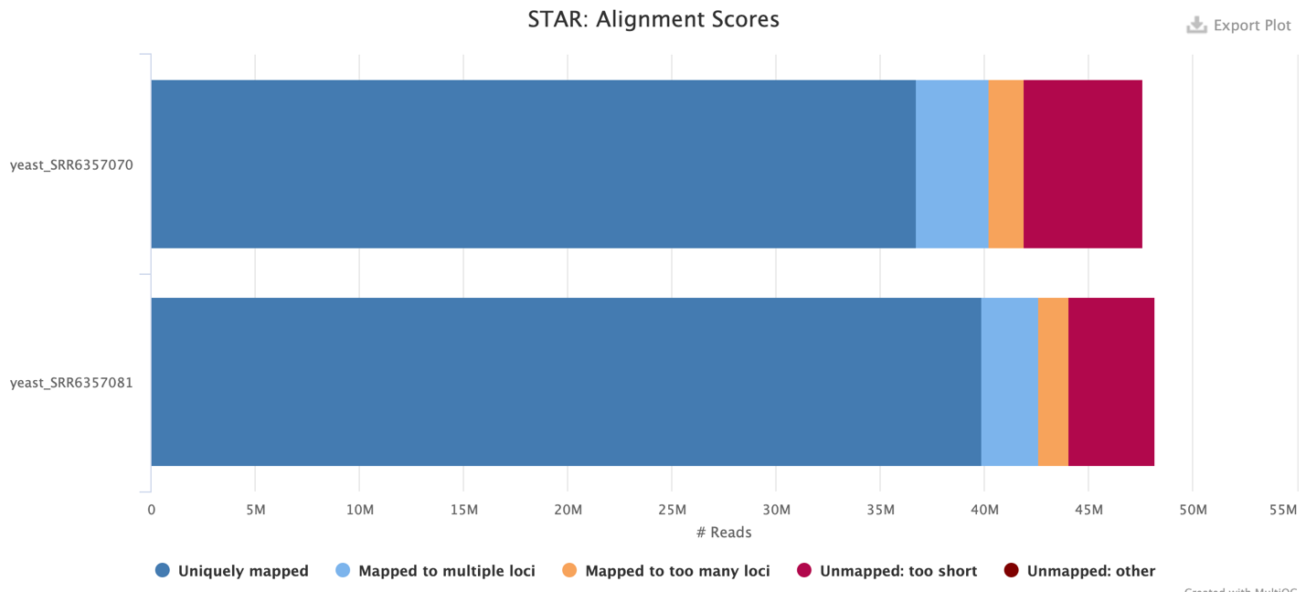

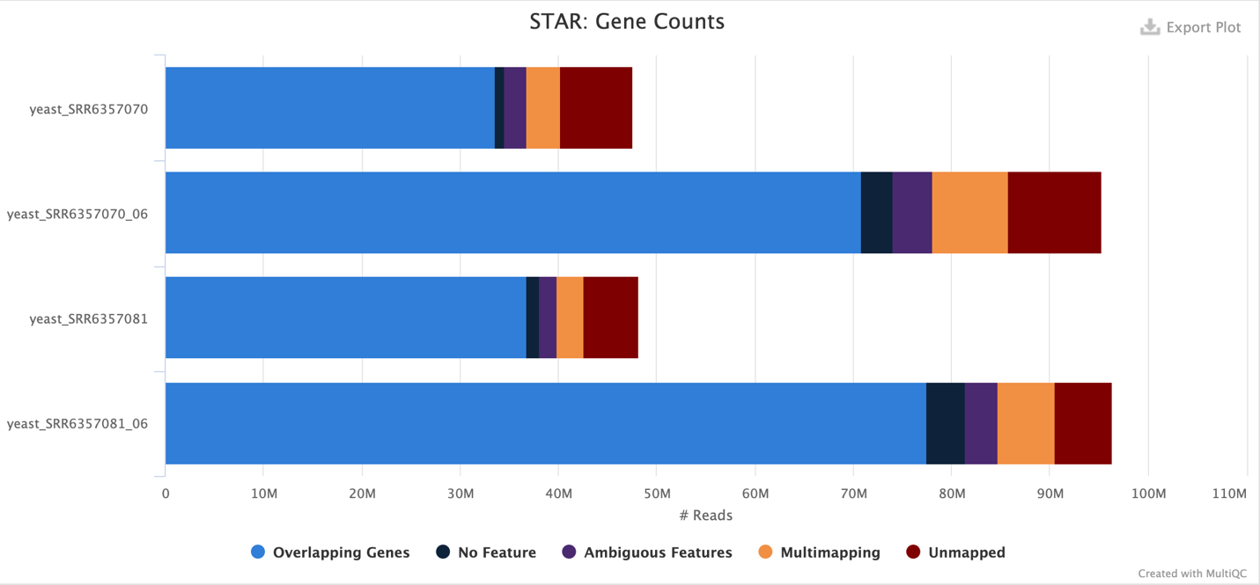
*Ignore the rows for yeast_SRR6357070_06 and yeast_SRR6357081_06; they are based on outdated data.

RSeQC’s infer_experiment results:

SRR6357070:
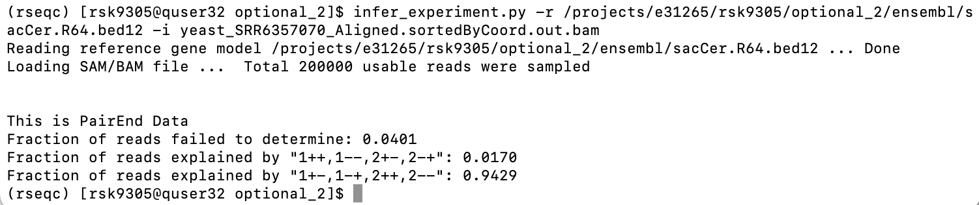

SRR6357081:
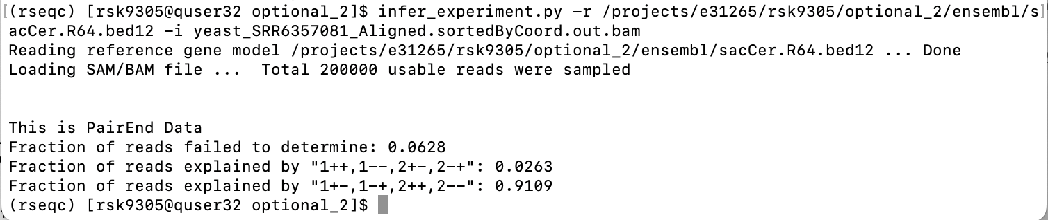

Inner distance results:

SRR6357070:

IGV Images:
PHO89:
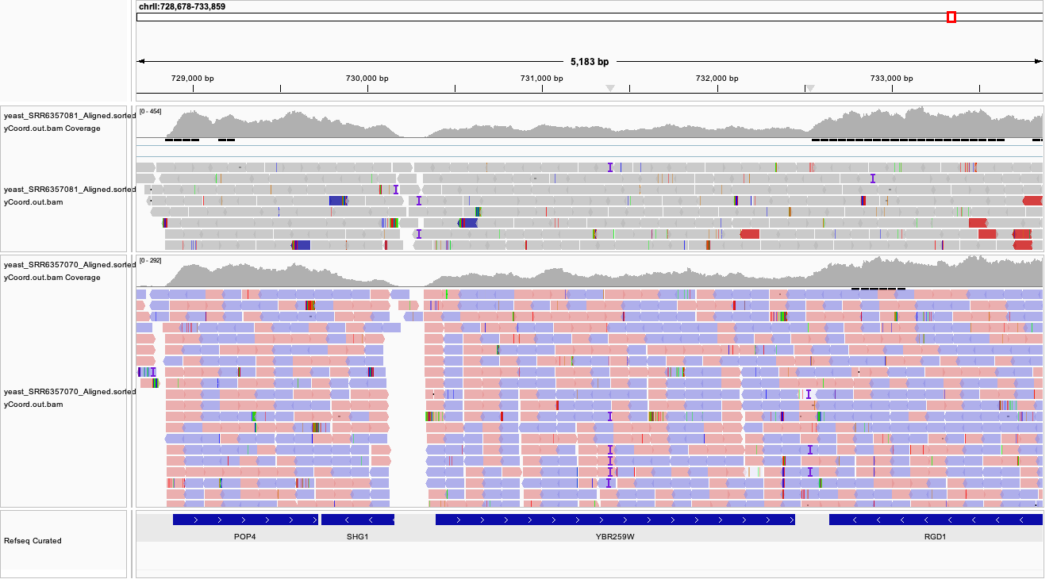

URA1:
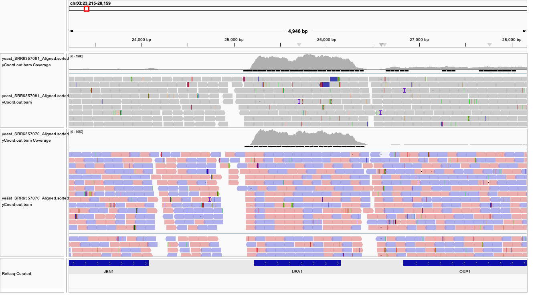

COS1:
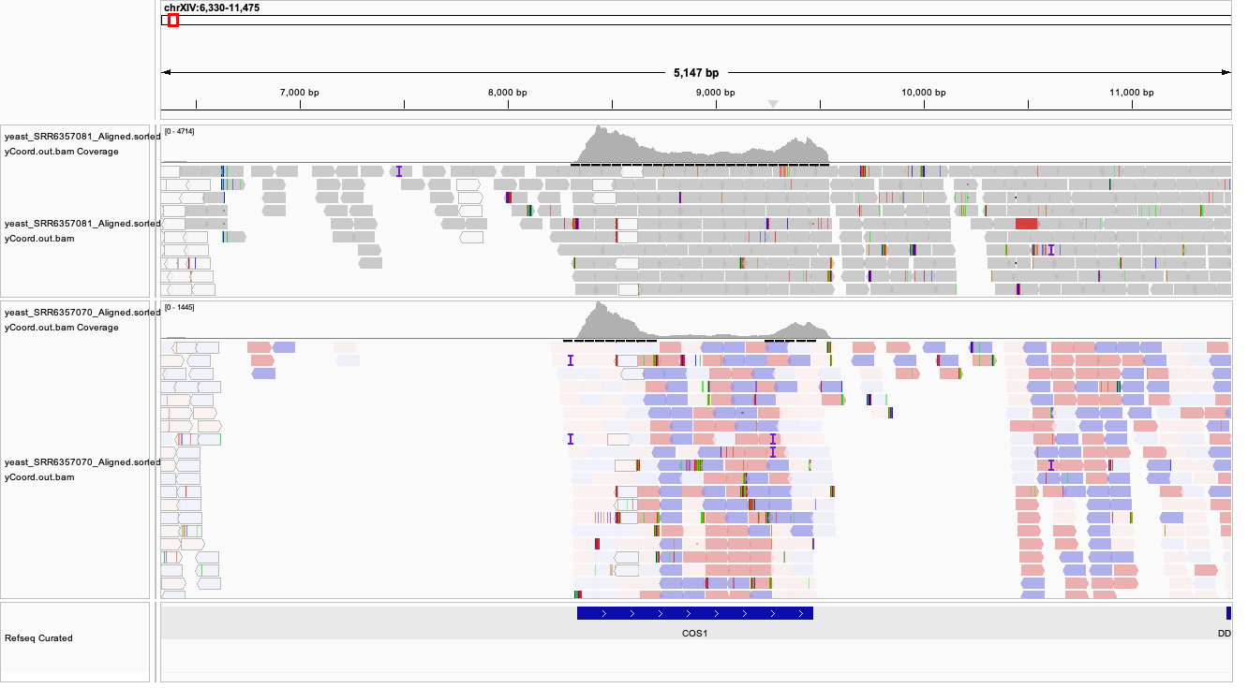

Discussion:
The levels of gene expression for the samples SRR6357070 and SRR6357081 appear to be quite similar. However, the expression for SRR6357081 appears to be a bit higher. The comparison of tracks at the COS1 gene highlights the increased gene expression for the SRR6357081 sample the best.

